INFORMATION SHEET AGE 0-6
To be shown/read to the child by the parent/guardian

UK Histiocytosis Registry

White blood cells tell each other about bugs in your body and then eat them to stop you from getting ill.
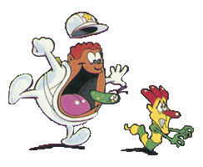
©Procidis (Image issued from the animated tv series "Once upon a time...Life".)

We want to find out more about white blood cells and what happens when they don’t work properly.

To do this we would like to use some of your blood and operation samples that were taken by the nurses and doctors at the hospital. Then we can find out something new. This is called research.

You don’t have to let us have your samples, it is up to you and your mum and dad or guardian, so talk to your family, doctor or nurse to decide if you want to.

If you say yes but then decide you don’t want to let us have the samples in the future, just tell your parents or doctor, no one will mind.

Hopefully the new things we find by research will help people like you in the future.

